THE REVISING PROCESS OF WRITING
The revising stage comes after drafting in the writing process.
It is the phase where you re-see your draft—looking again at your ideas, organisation, and clarity—and make changes so your message is stronger and easier for a reader to understand.

📝 Key Characteristics of Revising
Focus on Ideas and Organisation, Not Tiny Errors
The main goal of revising is to improve the content of your writing. You look at the big picture: Are your ideas clear? Is anything missing, confusing, or off topic? Spelling and commas come later in editing.
Rethinking and Reshaping the Draft
Revising often means adding, removing, moving, or rewriting parts of the draft. You may change your introduction, rearrange paragraphs, or replace weak examples with stronger ones.
Using Feedback and Your Writing Goals
You use comments from peers or your teacher, checklists, and your original purpose or assignment to decide what needs to change. Feedback helps you see your writing from the reader’s point of view.
Multiple Versions
A revised draft is not final. Writers often go through several rounds of revising, each time making the ideas clearer, the structure stronger, and the explanations more complete.

🏗️ The Writer’s Role in the Revising Stage
Clarify the Main Idea or Thesis
Reread your introduction and thesis statement. Ask: Does this clearly show what my piece is about? Adjust or rewrite it if needed.
Strengthen Paragraphs and Support
Check each body paragraph:
- Does it focus on one main idea?
- Does it include enough specific details, examples, or evidence?
Add missing information, cut off-topic sentences, and replace weak points with stronger ones.
Improve Organisation and Flow
Look at the order of your paragraphs and sentences.
Move parts around so ideas build logically, from introduction to conclusion. Combine or split paragraphs if this makes the structure clearer.
Enhance Transitions and Connections
Add or revise transition words and phrases so ideas connect smoothly (for example: first, however, as a result, in addition, finally). Make sure each sentence links clearly to the next.
Revise for Audience and Tone
Ask yourself: Will my reader understand this?
Change word choice, explanations, or examples so they fit your audience and purpose (informing, persuading, explaining a process, etc.).
Prepare for Editing
Once you are satisfied with the ideas and organisation, you are ready for the next stage—editing and proofreading, where you correct grammar, spelling, punctuation, and formatting.

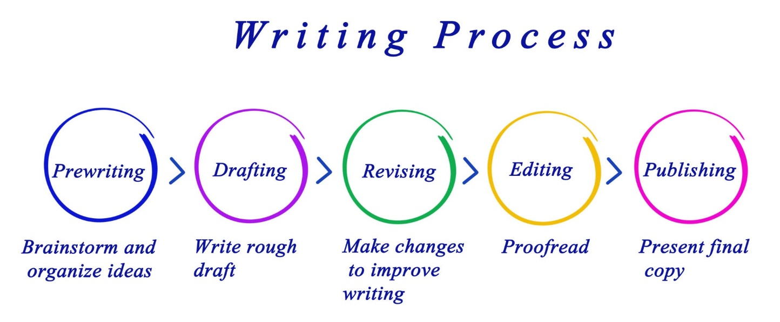
Making the Writing Process Work for You
What makes the writing process so beneficial to writers is that it encourages alternatives to standard practices while motivating you to develop your best ideas. For instance, the following approaches, done alone or in combination with others, may improve your writing and help you move forward in the writing process:
- Start with the body paragraphs. A common error is to start drafting an essay at the introduction since that’s the first paragraph in a final draft, but you cannot effectively introduce something you do not yet know. You can’t introduce someone at a social gathering if you have no idea who that person is, and you can’t effectively introduce body paragraphs that you haven’t drafted yet. So draft several body paragraphs before going back and creating an introduction that discusses them.
- Begin writing with the part you know the most about. You can start with the third paragraph in your outline if ideas come easily to mind. You can start with the second paragraph or the first paragraph, too. Although paragraphs may vary in length, keep in mind that short paragraphs may contain insufficient support. Readers may also think the writing is abrupt. Long paragraphs may be wordy and may lose your reader’s interest. As a guideline, try to write paragraphs longer than one sentence but shorter than the length of an entire double-spaced page.
- Write one paragraph at a time and then stop. As long as you complete the assignment on time, you may choose how many paragraphs you complete in one sitting. Pace yourself. On the other hand, try not to procrastinate. Writers should always meet their deadlines.
- Take short breaks to refresh your mind. This tip might be most useful if you are writing a multi-page report or essay. Still, if you are antsy or cannot concentrate, take a break to let your mind rest. But do not let breaks extend too long. If you spend too much time away from your essay, you may have trouble starting again. You may forget key points or lose momentum. Try setting an alarm to limit your break, and when the time is up, return to your desk to write.
- Be reasonable with your goals. If you decide to take ten-minute breaks, try to stick to that goal. If you told yourself that you need more facts, then commit to finding them. Holding yourself to your own goals will create successful writing assignments.
- Keep your audience and purpose in mind as you write. These aspects of writing are just as important when you are writing a single paragraph for your essay as when you are considering the direction of the entire essay.
Of all of these considerations, keeping your purpose and your audience at the front of your mind is the most important key to writing success.
Your purpose will guide your mind as you compose your sentences. Your audience will guide word choice. Are you writing for experts, for a general audience, for other college students, or for people who know very little about your topic? Keep asking yourself what your readers, with their background and experience, need to be told in order to understand your ideas. How can you best express your ideas so they are totally clear and your communication is effective?

Exercise 1
Using a subject of your choosing (such as one you have outlined in previous exercises), describe your purpose and your audience as specifically as you can. Keep these responses near you during future stages of the writing process.
My purpose: ____________________________________________
____________________________________________
____________________________________________
My audience: ____________________________________________
____________________________________________
____________________________________________

. The Basic Elements of a First Draft
If you have been using the information in this chapter step by step to help you develop an assignment, you already have both a formal topic outline and a formal sentence outline to direct your writing. Knowing what a first draft looks like will help you make the creative leap from the outline to the first draft. A first draft should include the following elements:
- An introduction that clearly identifies the subject, the thesis, and the main ideas to come (in the order that they will appear).
- A thesis statement that presents the main claim of the entire piece of writing.
- A topic sentence in each paragraph that states the main point of the paragraph and implies how that main point connects to the thesis statement.
- Supporting sentences in each paragraph that develop or explain the topic sentence. These can be reasons, specific examples, explanations, comparisons, facts, or other strategies that help support the main points and the thesis.
- A conclusion that emphasizes the most important ideas and interpretations.
See the chapter Paragraphs for information on topic sentences and other key parts of a paragraph. See the chapter Essays for more information on thesis statements and other key parts of an essay.
Examples of Starting a Draft
Now we are finally ready to look over Mariah’s shoulder as she begins to write her essay about digital technology and the confusing choices that consumers face. As she does, you should have in front of you your outline, with its thesis statement and topic sentences, and the notes you wrote earlier in this lesson on your purpose and audience. Reviewing these will put both you and Mariah in the proper mind-set to start.
The following is Mariah’s thesis statement.
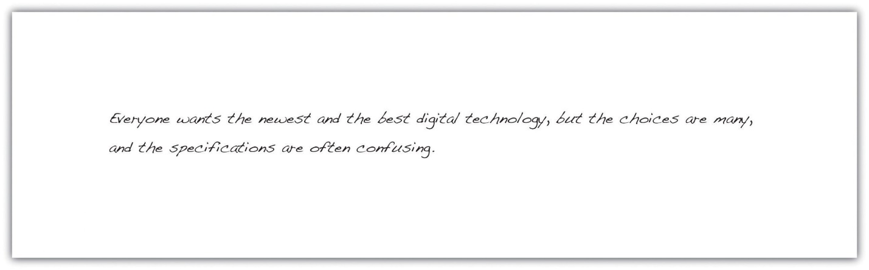
Everyone wants the newest and the best digital technology ,but the choices are many, and the specifications are often confusing
Here are the notes that Mariah wrote to herself to characterize her purpose and audience.
Mariah's notes to herself
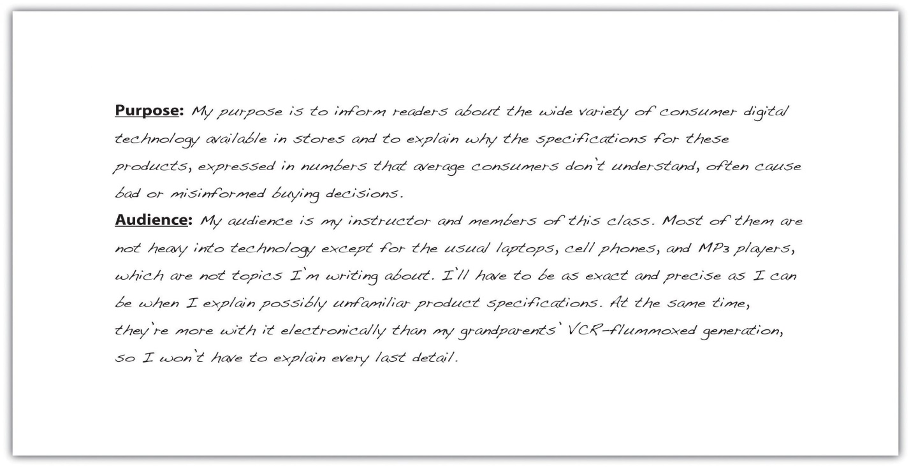
Mariah chose to begin by writing a quick introduction based on her thesis statement. She knew that she would want to improve her introduction significantly when she revised. Right now, she just wanted to give herself a starting point.
With her thesis statement and her purpose and audience notes in front of her, Mariah then looked at her sentence outline. She chose to use that outline because it includes the topic sentences. The following is the portion of her outline for the first body paragraph. The Roman numeral II identifies the topic sentence for the paragraph, capital letters indicate supporting details, and Arabic numerals label sub points.
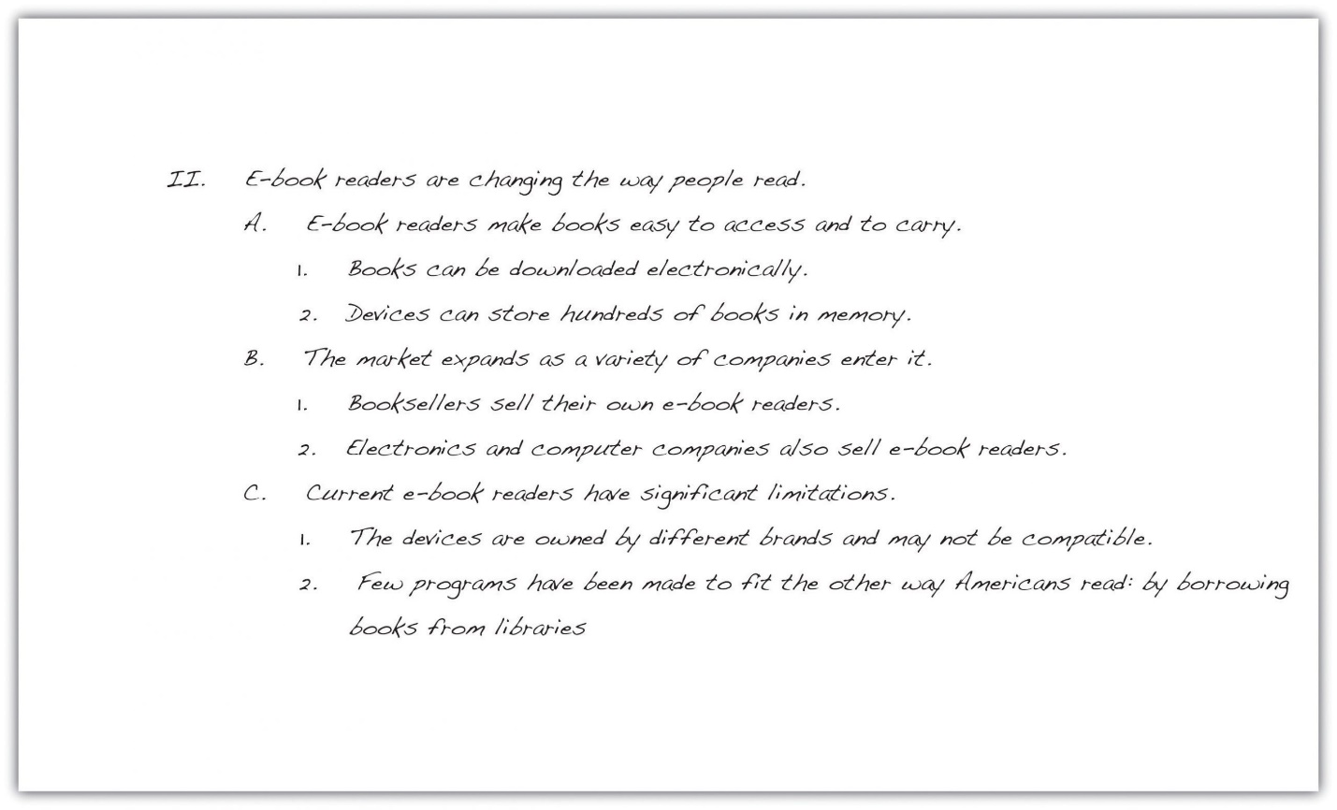
Mariah then began to expand the ideas in her outline into a paragraph. Notice how the outline helped her guarantee that all her sentences in the body of the paragraph develop the topic sentence.

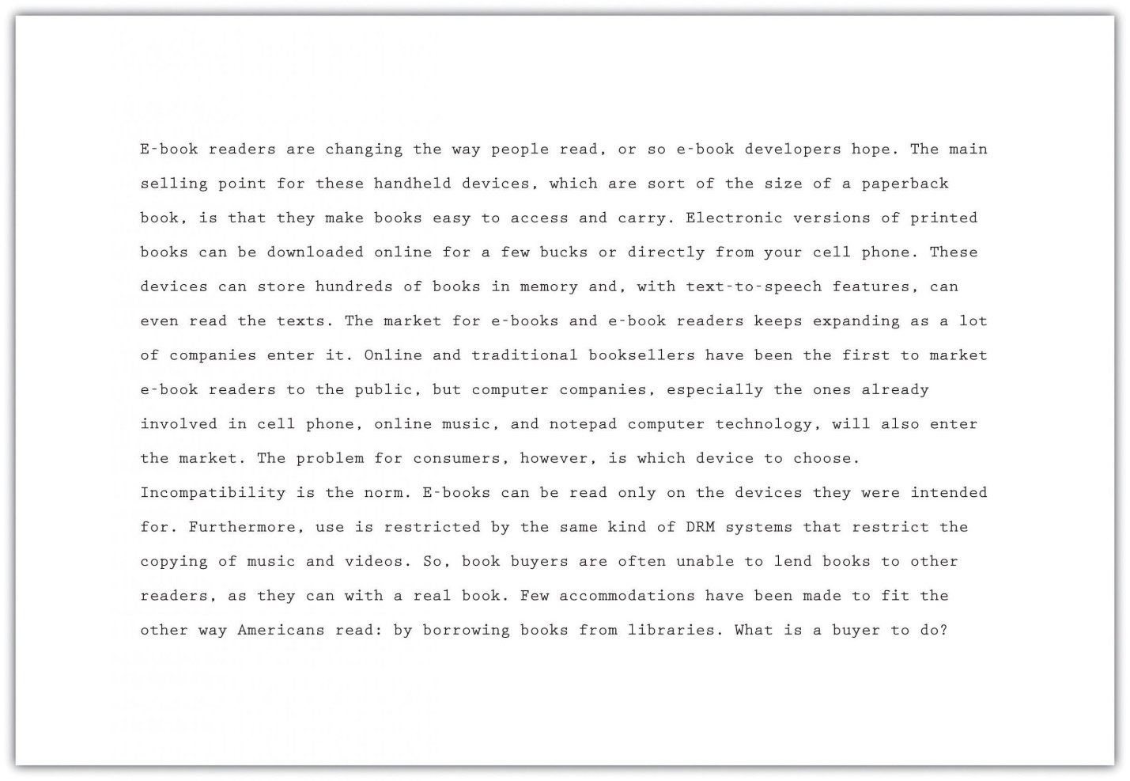

Tip
When you make major changes to a draft, save the different version as a different document with a different title—such as draft 1, draft 2, and so on—so that you will have a complete history of drafts. This can come in handy when later changing your mind about a direction you went with a draft.

END OF LESSON.

